PRESS RELEASE
For immediate release
August 6, 2017

DOÑA LUCY WINS 45TH USVI OPEN/ATLANTIC BLUE MARLIN TOURNAMENT

St. Thomas, U.S. Virgin Islands. A total of five blue marlin released in three days of fishing earned Doña Lucy the top boat prize in the 45thannual USVI Open/Atlantic Blue Marlin Tournament (ABMT). Incredibly, the San Juan, Puerto Rico-based team scored four of these fish on today’s last day of fishing to take the trophy over A1A, which also released five blue marlin total, but had to settle for second place based on time. Doña Lucy’s triumph was in a Davy versus Goliath-style as the 41’ Ronin sports fisher was half the size of other ABMT competitors.
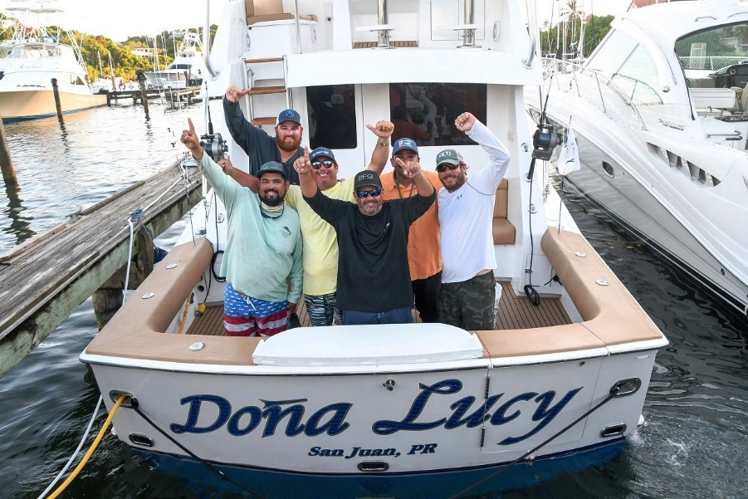
Photo: Top Boat, Doña Lucy, from Puerto Rico. L to R: Bryan Ramos, Jose De Veer, Rafael Caicedo, Efrain Rodriguez, Captain Juan Garcia, and Joselo Hernandez. Credit: Dean Barnes.

“We had a team meeting last night and our captain, Juan Garcia, said he had a feeling it would be a good idea to fish the tournament’s last day up off Anegada,” says Doña Lucy angler, Rafael Caicedo. “This is where we released our first fish on Day 1. We fished the North Drop yesterday, with all the rest of the boats, and didn’t catch a thing. The idea was, as the smallest boat in the tournament, we had to break away from the pack. Luckily, we did. We found a small patch of blue water without weed and trolled in that patch.”

The Doña Lucy team raised its first fish of the day late morning, but it wouldn’t bite. Then, barely a half hour later, anglers Bryan Ramos and Efrain Rodriguez hooked up a blue marlin double header and landed both. With barely time to set the baits back out, Rodriguez hooked, caught and released a blue marlin weighing an estimated 500 pounds.

“Two minutes later, Efrain hooked up the big girl. It was about a 650 to 700-pound blue marlin and took 2 hours and 15 minutes to fight and release. It was during that time that A1A almost caught up to us. However, we were the first to reach five when we released that big fish,” says Caicedo.

There were three secrets to the Doña Lucy’s team’s success. One, the skilled anglers successfully caught everything that bit. Secondly, dead bait rather than lures was the team’s preferred fish attracting method. Third, the anglers and crew had a great boat.

“We just finished building the boat and this is only the second tournament we’ve fished,” says Caicedo.

The beautiful little Ronin was the last unfinished hull sitting in the factory when the Ponce, Puerto Rico-based yacht builder closed. Two weeks before the hull was to be sent to the crushers, says Caicedo, he and his fellow fishing team moved it to a small shed and spent five years finishing her. This is the little Ronin’s debut summer.

“It’s the little boat that could and did,” says Caicedo.

A1A, a 72’ Jim Smith based out of Florida, finished in second place in the boat standings with five blue marlin releases. Angler/owner, Bill Waldorf, earned Top Angler, caught and released all five blues. Business Stinks, a 72’ Merritt with Brazilian-based owner/angler Lucas Abud aboard, ended third with three blue marlin in the boat standings.

The 8-boat tournament fleet released a total of 22 blue marlin in the three days of fishing.

Boats competing in the ABMT were A1A, Angela, Business Stinks, Cheeseburger, Doña Lucy, Gulf Rascal, Reel Tight and Sodium.

The ABMT was run this year as a team tournament under IGFA rules only, without the call for competitors to adhere to additional special tournament rules such as the need for anglers to rotate rods hourly.

On land, the 5th Annual MarlinFest concluded with a Shrimp Boil and Caribbean Show in the parking lot of the Red Hook Shopping Mall.

The ABMT and MarlinFest benefit the locally-registered not-for-profit Marine Vocational Program (MVP). The MVP’s goal is to serve as avocational institution that provide U.S. Virgin Islands youth with a career path into the marine/hospitality/tourism industries. Current MVP programs include learn-to-swim, sailing, scuba diving and small boat handling and operation skills.

Started by Chuck Senf back in 1972, the ABMT has evolved into one of the most competitive saltwater sports fishing events in the world or the ‘Super Bowl of Sports Fishing’.

Media Contact:
Carol Bareuther
Cell: (340) 998-3650
bareuther@earthlink.net

