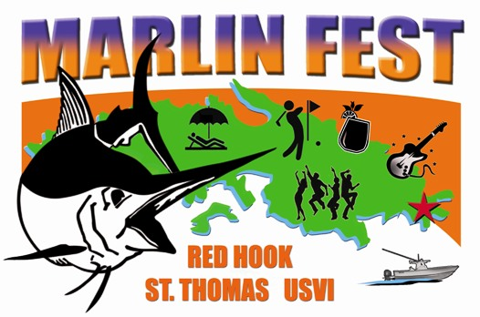


PRESS RELEASE
For immediate release
August 9, 2014

REEL AFFAIR TAKES OVER LEAD DAY 3 –
42ND USVI OPEN/ATLANTIC BLUE MARLIN TOURNAMENT

St. Thomas, U.S. Virgin Islands. The bite stayed strong on the third day of competition in the 42nd USVI Open/Atlantic Blue Marlin Tournament (ABMT) and so did the performance of the team aboard Carlos Ramirez’ 56’ Viking, Reel Affair. The San Juan, Puerto Rico-based anglers and crew released three blue marlin by noon, taking away the lead for the first time since the tournament started on Thursday from the Miami, Florida-based crew aboard the 68’ Paul Mann, Jichi. What’s more, Reel Affair secured its place at the top of the pack with its fourth release of the day, making them the only boat so far with 10 blue marlin releases.

“We fished off Anegada again and I knew we were in the right area when we released our first blue marlin by 9:30 am,” says Ramirez. “All we can do now is what we’ve been doing all along – be well prepared and hope our luck shows up again.”

No doubt some of Ramirez and his team’s good fortune comes from Capt. Juan Garcia. Garcia is normally at the helm on Peje, Carlos Garcia’s 47’ Cabo, a boat that won the ABMT in 2007 and 2012. Peje’s Garcia was unable to attend this year’s tournament, so Ramirez asked to borrow his friend’s captain.

“We feel blessed to have such a great team,” says Ramirez.

The Jichi team rebounded from going fishless the day before with the release of two blue marlin. This gave them 9 blue marlin total and a firm second place.

Wave Paver, Port Canaveral, Florida’s Jr. Davis’ 61-foot Garlington’s team released another two blue marlin for six total and a third place on the scoreboard.

Meanwhile, the team aboard Hook ‘n Bull, a 63’ Lightning out of Port Aransas, Texas, had a great day with three blue marlin releases.

“The first was a double header. We caught them both. Real fast. Real nice,” says angler Devin Silas, of Stuart, Florida, who released one of these fish.

This is the first season Hook ‘n Bull is fishing in the Virgin Islands.

“We came down at the end of May after fishing in the Dominican Republic,” says owner/angler, Patrick ‘Jr’ Turnbull. “I guess you could say we’ve had some good practice in the local waters in the run up to this tournament.”

A total of 29 blue marlin were released Day 3 or 74 total so far for the tournament.

The ABMT anglers take a Lay-Day on Sunday. But the competition continues on land at the MarlinFest ‘Boy Scout’ Golf Tournament at Mahogany Run. Designed by world-renowned architects George and Tom Fazio, the 6000 yard, Par 70 Mahogany Run Golf Course attracts thousands of visitors each year including celebrities and Presidents alike.

The angling action concludes Monday capped off with an evening Awards Ceremony.

Started by Chuck Senf back in 1972, the ABMT has evolved into one of the most competitive saltwater sports fishing events in the world. The ABMT is fished under International Game Fishing Association (IGFA) rules, and is overseen by a professional ‘Board of Captains’ and well-qualified observers. The tournament benefits the U.S. Virgin Islands Field Service Area, part of the National Capital Area Council of the Boy Scouts of America (BSA) and it helps to fund the Marine Vocational Program (MVP), which is operated and funded under the BSA by the organizers of the ABMT. The MVP program teaches local scouts to swim, scuba dive, sail and more in an effort to interest them to pursue a career in the marine industry.

MarlinFest: 1st Annual Chowder Challenge

Eight St. Thomas restaurants competed in the 1st Annual Chowder Challenge, part of MarlinFest, a weeklong of spectator-friendly activities planned around the ABMT. A team of five judges named Fish Tails’ Bar & Grill’s Mahi Corn Chowder the first place $500 winner.

“It’s one of our signature dishes,” says Fish Tails’ Paula Druse.

Hook, Line & Sinker Seafood Restaurant in Frenchtown placed second with Chef Samuel Harry Ralph’s Seafood Chowder and won $300, while Senior Frog placed third and was awarded $200 thanks to Chef Sergio Rodriguez’s Clam Chowder.

“All of the chowders were really amazing,” says head judge, Marleen Dykhuis. “There was a really small point spread between all of the entries.”

For more information, call: (340) 775-9500 or (888) 234-7484 or Email: loveto@islands.vi. Or, follow the tournament action on Facebook. Daily updates and results will be posted at: www.abmt.vi

-##-

