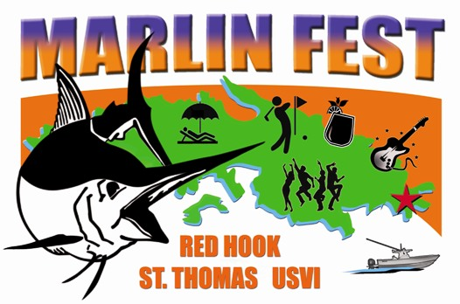


PRESS RELEASE

For immediate release
August 7, 2014

7 RELEASES EARN JICHI THE DAY 1 LEAD IN 42ND USVI OPEN/ATLANTIC BLUE MARLIN TOURNAMENT

St. Thomas, U.S. Virgin Islands. The bite proved red hot for the anglers and crew aboard the 68’ Paul Mann, Jichi. The Miami, Florida-based team released a whopping 7 blue marlin on the first day of fishing in the 42nd USVI Open Atlantic Blue Marlin Tournament (ABMT), to the lead the 22-boat fleet.

“It was an epic day,” says team leader, Ernie Portuondo. “We pulled the hook on the first fish, and after that it was boom, boom, boom, we had five releases by Noon. Then, it went quiet until 4 pm when the bite picked up again and we released another two, one right after another, the last release six minutes before lines out for the day.”

Jichi’s anglers – Albert Castro, Luis Isaias, Ricky Querejeta and the boat’s builder, Paul Mann – caught one blue marlin on pitch baits and the remaining six by trolling a variety of colors of lures. They fished off the British Virgin Island of Anegada.

Querejeta released three of Jichi’s blue marlin, placing him in the lead for Top Angler.

“We have a great team, fish hard and have a lot of fun doing it,” says Portuondo. “It creates a great karma. That’s how we win or place in so many tournaments.”

Jichi finished third in the 2013 ABMT.

The San Juan, Puerto Rico-based team aboard the 56’ Viking, Reel Affair, finished second by releasing four blue marlin. Reef Affair angler, Michael LaPorte, caught the team’s first blue marlin, which was also the first fish released for the tournament.

“We had good luck today,” says Reel Affair’s owner/angler, Carlos Ramirez.

Rounding out the top three boats on the ABMT’S leaderboard was Casca Dura, a Brazilian-based 80’ Merritt whose anglers released two blue marlin.

Fourteen of the 22-boat fleet gained a foothold on the scoreboard by catching one or more of the first day’s collective 25 blue marlin releases. One of these was 2013 Top Boat defending champion, Wave Paver, a 61-foot Garlington owned by Port Canaveral, Florida’s Jr. Davis.

“We saw two fish today and released one,” says Davis. “The bite is picking up and we’re looking forward to tomorrow.”

The angling action continues Friday, Saturday and Monday, when teams set their sights on catching and releasing the most blue marlin first.

The public can catch the spirit of the sport by walking the docks and watching the big rigs come in around 6:30 pm. The number of flags flying off a boat’s outriggers indicate the number of marlin released that day. The more flags, the more marlin the boat released, and the winner is the one who releases the most blue marlin first. Anglers in this conservation-oriented tournament have not killed a blue marlin since 1986. Commemorative tournament T-shirts, hats and more with original art designed by famous marine artist Carey Chen will be on sale each night of the event.

On Saturday and Sunday, the MarlinFest ‘Wet N' Wild’ two-day Center Console ‘All Billfish, Wahoo and Yellowfin Tuna’ tournament takes place. This event is for those anglers who enjoy big game fishing on standup tackle. Charter boats are available; see website for details (www.abmt.vi/pages/marlinfest_cc.htm).

On shore Saturday, there’s a whole day of MarlinFest activities for the public called the Red Hook ‘Jump Up’ at AYH. First, there’s the Arts & Crafts and West Indian Food Fair from 11 am to 8 pm. Then, the Chowder Challenge of the restaurants happens from 4 pm to 8 pm. The evening caps off with a Caribbean-style ‘Jump Up’ show starting at 8:30 pm.

The ABMT anglers take a Lay-Day on Sunday. But the competition continues on land at the MarlinFest ‘Boy Scout’ Golf Tournament at Mahogany Run. Designed by world-renowned architects George and Tom Fazio, the 6000 yard, Par 70 Mahogany Run Golf Course attracts thousands of visitors each year including celebrities and Presidents alike.

The ABMT concludes on Monday with an Awards Ceremony.

Started by Chuck Senf back in 1972, the ABMT has evolved into one of the most competitive saltwater sports fishing events in the world. The ABMT is fished under International Game Fishing Association (IGFA) rules, and is overseen by a professional ‘Board of Captains’ and well-qualified observers. The tournament benefits the U.S. Virgin Islands Field Service Area, part of the National Capital Area Council of the Boy Scouts of America (BSA) and it helps to fund the Marine Vocational Program (MVP), which is operated and funded under the BSA by the organizers of the ABMT. The MVP program teaches local scouts to swim, scuba dive, sail and more in an effort to interest them to pursue a career in the marine industry.

For more information, call: (340) 775-9500 or (888) 234-7484 or Email: loveto@islands.vi. Or, follow the tournament action on Facebook. Daily updates and results will be posted at: www.abmt.vi

Media Contact:
Carol Bareuther
Tel: (340) 774-2736
Cel: (340) 998-3650
bareuther@earthlink.net

-##-

