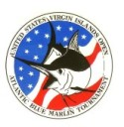

PRESS RELEASE
For immediate release
August 21, 2013

WAVE PAVER WINS 41ST USVI OPEN/ATLANTIC BLUE MARLIN TOURNAMENT

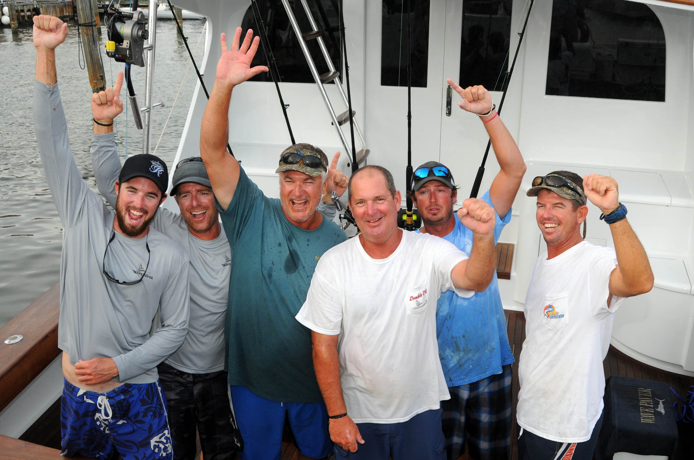
Photo: Team Wave Paver L to R: Ryan House, Jason Parker, Jr. Davis (Top Angler), Scott Glasscock, Jerry Owens and Capt. Jason Sinclair.
Credit: Dean Barnes

St. Thomas, U.S. Virgin Islands. The Wave Paver team pulled away from the pack and lengthened their lead with four blue marlin releases today – tallying a whopping nine total in four days of fishing – to win the 41st USVI Open Atlantic Blue Marlin Tournament (ABMT) or ‘Boy Scout Tournament’ so nicknamed for the event’s chief beneficiary. What’s more, Jr. Davis, owner/angler of the Port Canaveral, Florida-based 61-foot Garlington, released six of the blue marlin to earn Top Angler and pocket $10,000 in cash.

“The first two day days were good and we finished the second day in the lead with five releases,” recaps Wave Paver’s Davis. “Then, we had a bad day the third day. Didn’t catch a thing. We headed out on the lay day to fish and found a place on the (North) Drop that was productive for us. We headed back there today and it all came together for us.”

Eight boats were tied for first place with five blue marlin releases apiece going into today’s last day of tournament fishing. Jichi, a 68-foot Paul Mann homeported in Florida and helmed by Capt. Gene Lenow, jumped into the lead early by being the first boat to release six blue marlin with an early morning catch.

“Jichi got the jump on us and we knew we needed to get going,” tells Wave Paver’s Davis. “It was around 9:30 to 10 a.m. that I released a blue that bit on the pitch, and then another 10 to 20 minutes later. That put us back in the lead with seven releases. There’s a bunch of really good boats fishing there so we knew that anything could still happen.”

Wave Paver’s Davis released his third blue marlin of the day mid-afternoon, followed by a fourth released 15 minutes before lines out.

“We knew we had it after that fourth fish today,” Davis says. “We have a great team of guys, have fished together a long time and have a lot of fun together.

This is the first time Davis and his Wave Paver team have fished in the ABMT.

“It’s always been a dream of mine to fish this tournament,” Davis tells.

Casca Dura, a Brazilian-based 80-foot Merritt, finished second with seven blue marlin releases, five of them by angler Lucas Abud, who also ended as the runner-up top angler.

“This is our first season fishing in the Virgin Islands,” says Casca Dura’s Abud. “We fished the July Open and liked it so much we decided to stay and fish this tournament too.”

Abud adds, “We’ve fished off Anegada the other three days. Today, mid-morning, we decided to pull in the lines and head to the North Drop. That’s when we caught and released our two blue marlin.”

Jichi finished third with six blue marlin releases, while Black Gold’s Mike McCarthy ended third in angler standings with four blues.

In other awards, sixteen-year-old Alex Chouest, aboard Chach, won Top Junior Angler with two releases. Laura Coburn, fishing from Debaitable, scored Top Woman Angler with three blues, while the Top Local Charter Boat award went to Marlin Prince with three releases.

The 28 boat fleet released a total of 115 blue marlin in four days of fishing

Started by Chuck Senf back in 1972 – and nicknamed The Boy Scout Tournament since a portion of the proceeds have always benefited the VI Council of the Boy Scouts of America, one of Senf’s favorite charities – the ABMT has evolved into one of the most competitive saltwater sports fishing events in the world. It’s one of legs of the prestigious Bermuda Triangle Series and Spanish Main Series.

The ABMT is fished under International Game Fishing Association (IGFA) rules, and is overseen by a professional Board of Captains and well-qualified observers. The ABMT benefits the V.I. Council, Boy Scouts of America.

For more information and full tournament results, visit www.abmt.vi or visit the event’s FaceBook page!

