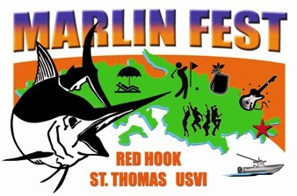

What is MarlinFest?
MarlinFest is a week of fun planned around the USVI Open/Annual Blue Marlin Tournament or better known as the “Boy Scout” Tournament. The week is packed with exciting daily events that will keep both our guests and local residents thrilled to be a part of the festivities! Proceeds from the Festival will go to the Marine Vocational Program (MVP), Boy Scouts of America.

Scheduled Events include: Welcome Cocktail Party; Music concert at Reichold Center; Red Hook ‘Jump Up’ Arts & Crafts and Food Festival; BVI Excursion; ‘Wet & Wild’ Center Console Tournament, Mahogany Run Golf Tournament and a BBQ Beach Party Farewell Bash!

MarlinFest invites you to participate in the
Red Hook Cultural “Food and Farm Feast”

Event Date:
See website: www.abmt.vi/pages/marlinfest_vendors.htm

American Yacht Harbor (upper street parking lot)
Local Food Vendors Featured: 9:30 a.m. – 6:30 p.m.

How it Works:
Food vendors will come out to showcase their favorite menu items during the MarlinFest ‘Food & Farm Feast.’ Individual booths will be set up during the day in AYH parking lot. Each vendor will sell their own offerings and should be prepared to see quite a few clients.

MarlinFest Will Provide:
Booth Space and Local Promotion

Participating Sellers of Food are Responsible For:
- Table, Tent (optional 10'x10') and their own trash receptacle.
- 8-foot skirted table cloth. Table cloth much reach within 3” of floor in front. No items underneath table may be viewed by the public.
- Plastic plates and utensils - forks, spoons, napkins.
- Decorate your table to make it look festive and appealing. We are trying to create this to represent the culture of the 1940’s – 60’s. Please dress in a colorful fashion.

Please let us know if you have any special needs, (i.e., use of grill or any other fire hazards). No gas deep fryers. Cooking shall be over traditional charcoal pots or grills only. No propane or electrical stoves allowed.

Event Information:

- Special parking is not provided vendors. Please arrive to set up early!
- Vendors will receive a map showing location of booth
- Setup begins at 8 a.m. You must be setup and ready to sell no later than 9:30 a.m.
- Festival patrons will purchase TICKETS to be used at bars for liquor, beer and wine. Food items will be purchased with CASH. Individual booths will be responsible for collecting cash and making change.

Note: There shall be no factory canned or bottled beverages sold from vendor booths. This includes sodas, beer, wine and hard liquor. The bars are run by MarlinFest volunteers and the proceeds go to the Boy Scouts. Please do not abuse this rule or you will not be invited back.

Entry Requirements:
- $50 Entry Fee. One vendor per booth.
- Payment Options
- Check - make checks payable to: Boy Scouts of America. Credit Cards (MC, Visa).
- Entry Deadline: 7/31.

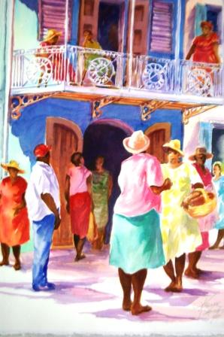

Back to: www.abmt.vi/pages/marlinfest_vendors.htm

