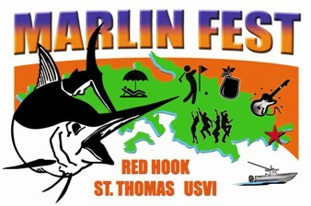

What is “Marlin Fest”?

Marlin Fest is a week of fun planned around the annual USVI Open/Atlantic Blue Marlin Tournament (40 years in continual operation!). The week will be packed with exciting daily events and one of the most popular will be the ‘Jump Up’ planned for Red Hook on TBA.

The parking areas on both sides of the street (marina and shopping mall) will be filled with food vendors and arts and crafts folks. On stage will be the music and entertainment! The area will be jumping from 10 a.m. till 11 p.m. and the proceeds of the affair will go towards the youth programs of the Boy Scouts of America. There are lots of opportunities to volunteer your time!

Scheduled events include: Welcome Cocktail Party; Music concert at Reichhold Center; Red Hook Arts, Crafts and Food Festival, BVI Excursion; Wet & Wild South Drop Fishing Tournament, Mahogany Run Golf Tournament and a BBQ Farewell Beach Bash!

Marlin Fest Volunteer Opportunities

- Marlin Darlings – Selling of raffle tickets and collecting great prizes from sponsors!
- Bar backs and runners – Keeping the bartenders happy!
- Litter Patrol – Helping to keep MF sparkling clean!
- Decorating Committee – Putting on our Happy Face!
- Parking Committee – Packing them in!
- Fest Patrol – Security eyes and ears!
- Bull Sharks – Set it up – Taking it down - Fix it fast!
- Doctor Fish and Nurse Sharks – Fast responders!
- Beach Bash Farewell Party – Sending them off with a smile!
- Friendly Fish Committee – Meet’ers and greeters!
- Movers and Shakers – Transportation Committee scheduling of hotel pickups and parking shuttle.

Telephone (340) 775-9500 or email: loveto@islands.vi Watch this website for schedule of planning meetings. Many Thanks!

Back to: www.abmt.vi/pages/marlinfest_vendors.htm

